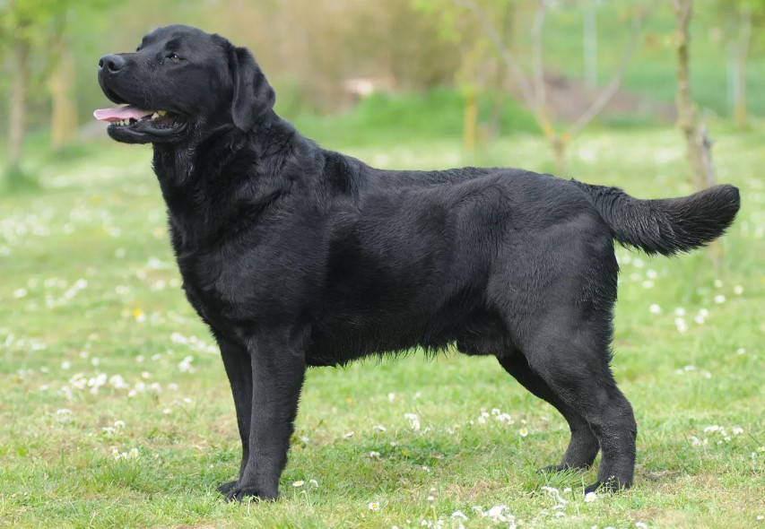

**“BUDDY”**

* ***Breed: Labrador Retriever***
* ***Type: Sporting***
* ***Height: 21.5-24.5 inches (male), 21.5-23.5 inches (female)***
* ***Lifespan: 10-12 years***
* ***Food: High-quality dog food with balanced nutrition.***

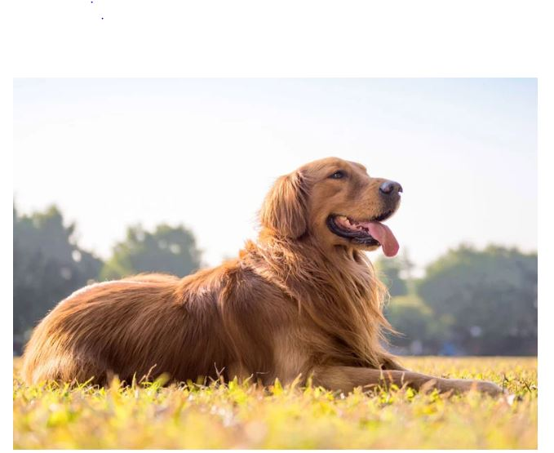

**“CHARLIE”**

* ***Breed: Golden Retriever***
* ***Type: Sporting***
* ***Height: 23-24 inches (male), 21.5-22.5 inches (female)***
* ***Lifespan: 10-12 years***
* ***Food: Balanced diet with lean proteins and grains.***

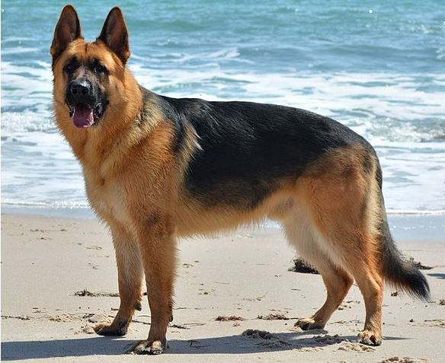

“BAILEY”

* + ***Breed: German Shepherd***
  + ***Type: Herding***
  + ***Height: 24-26 inches (male), 22-24 inches (female)***
  + ***Lifespan: 9-13 years***
  + ***Food: Protein-rich diet with a mix of vegetables.***

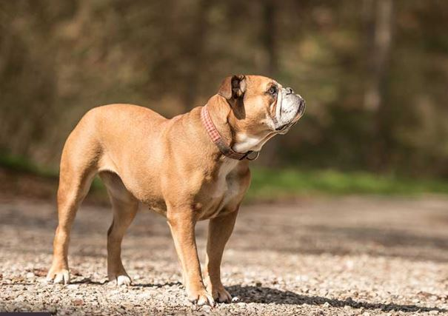

**“LUCY”**

* ***Breed: Bulldog***
* ***Type: Non-sporting***
* ***Height: 14-15 inches***
* ***Lifespan: 8-10 years***
* ***Food: Regular meals with attention to weight management.***

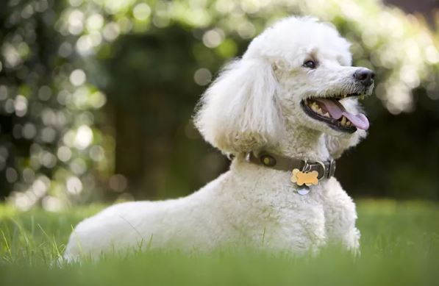

**“MOLLY”**

* ***Breed: Poodle***
* ***Type: Non-sporting***
* ***Height: Standard: over 15 inches, Miniature: 10-15 inches, Toy: 10 inches or under***
* ***Lifespan: 10-18 years***
* ***Food: High-quality dog food, can have specific dietary needs.***

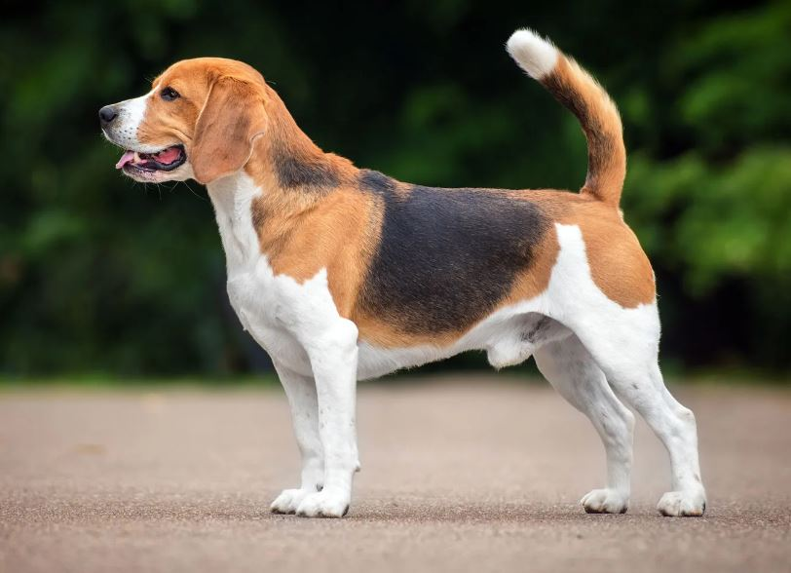

**“MAX”**

* ***Breed: Beagle***
* ***Type: Hound***
* ***Height: 13-15 inches***
* ***Lifespan: 10-15 years***
* ***Food: Well-balanced diet with portion control.***

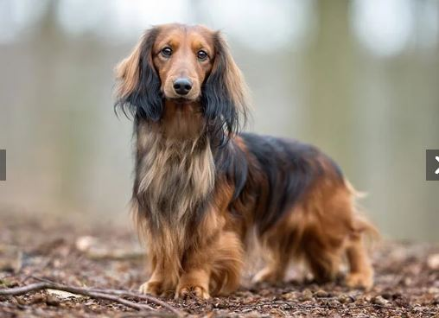

**“ZOE”**

* ***Breed: Dachshund***
* ***Type: Hound***
* ***Height: Standard: 8-9 inches, Miniature: 5-6 inches***
* ***Lifespan: 12-16 years***
* ***Food: Small, frequent meals to prevent obesity.***

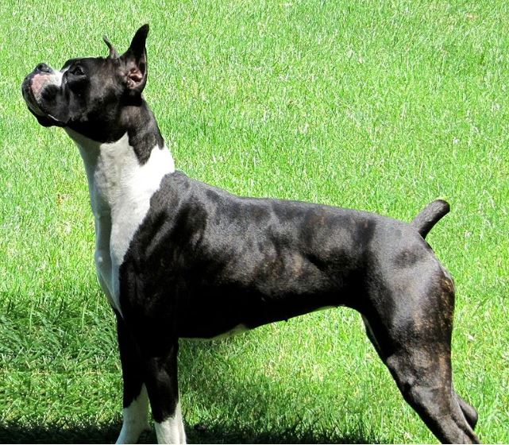

**“ROCKY”**

* ***Breed: Boxer***
* ***Type: Working***
* ***Height: 23-25 inches (male), 21.5-23.5 inches (female)***
* ***Lifespan: 10-12 years***
* ***Food: Protein-rich diet to support their muscular build.***

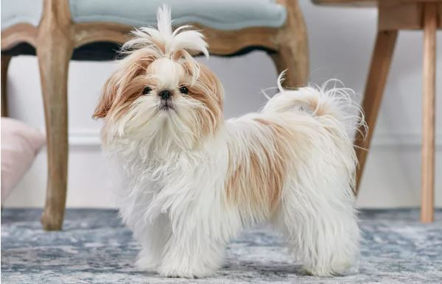

**“SOPHIE”**

* ***Breed: Shih Tzu***
* ***Type: Toy***
* ***Height: 9-10.5 inches***
* ***Lifespan: 10-18 years***
* ***Food: Small, regular meals with a focus on dental care.***

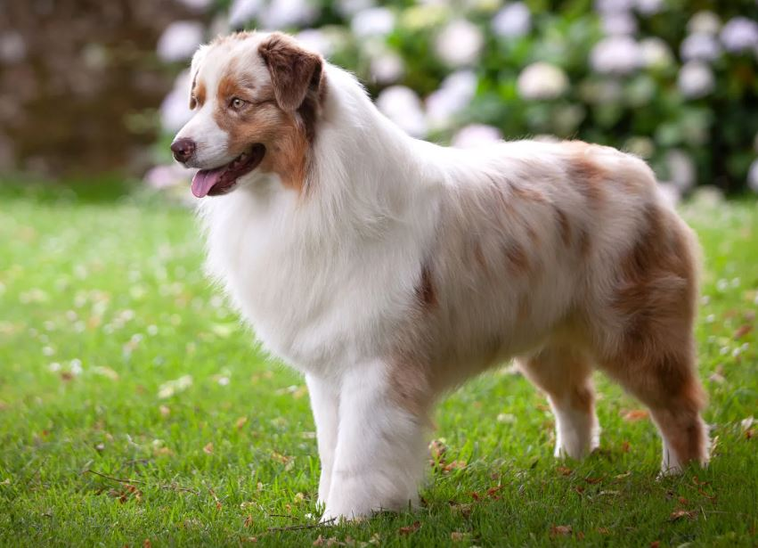

**“DUKE”**

* + ***Breed: Australian Shepherd***
  + ***Type: Herding***
  + ***Height: 20-23 inches (male), 18-21 inches (female)***
  + ***Lifespan: 12-15 years***
  + ***Food: Nutrient-dense diet for their high energy levels***

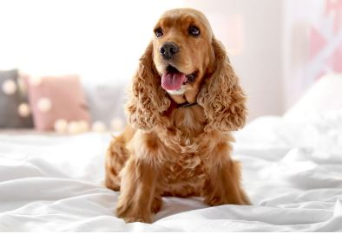

**“0SCAR”**

* + ***Breed: Cocker Spaniel***
  + ***Type: Sporting***
  + ***Height: 15-17 inches (male), 14-16 inches (female)***
  + ***Lifespan: 10-14 years***
  + ***Food: Regular meals with consideration for ear health.***

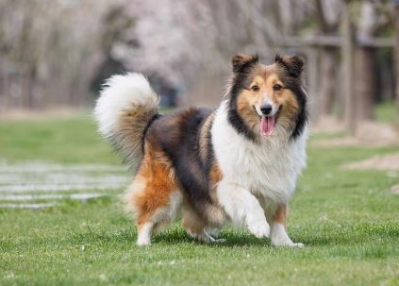

“**LOLA**”

* + ***Breed: Shetland Sheepdog***
  + ***Type: Herdin***
  + ***Height: 13-16 inches***
  + ***Lifespan: 12-14 years***
  + ***Food: Balanced diet with attention to coat health.***

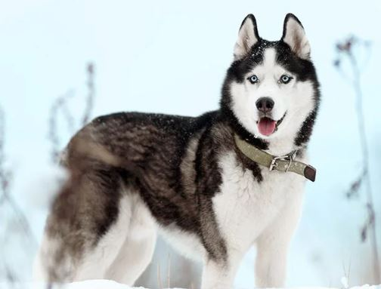

**“TUCKER”**

* ***Breed: Siberian Husky***
* ***Type: Working***
* ***Height: 21-23.5 inches (male), 20-22 inches (female)***
* ***Lifespan: 12-14 years***
* ***Food: High-protein diet with a good balance of fats.***

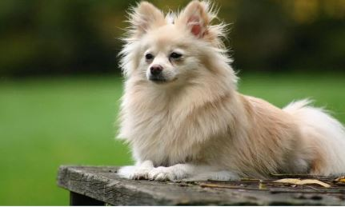

**“COCO”**

* ***Breed: Pomeranian***
* ***Type: Toy***
* ***Height: 6-7 inches***
* ***Lifespan: 12-16 years***
* ***Food: Small, frequent meals with a focus on dental care.***

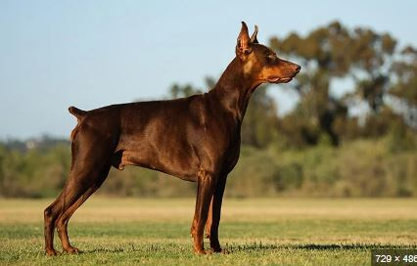

“LUNA”

* ***Breed: Doberman Pinscher***
* ***Type: Working***
* ***Height: 26-28 inches (male), 24-26 inches (female)***
* ***Lifespan: 10-13 years***
* ***Food: High-quality diet to support their energy and muscle needs***.